

*Geophysical Research Letters*

Supporting Information for

**Variability of the ocean carbon sink in MPI-ESM large ensemble simulations**

Hongmei Li1, Tatiana Ilyina1

1 Max Planck Institute for Meteorology, Bundesstraße 53, 20146 Hamburg, Germany.

**Contents of this file**

Text S1 to Sx

Figures S1 to Sx

Tables S1 to Sx

Text S1.

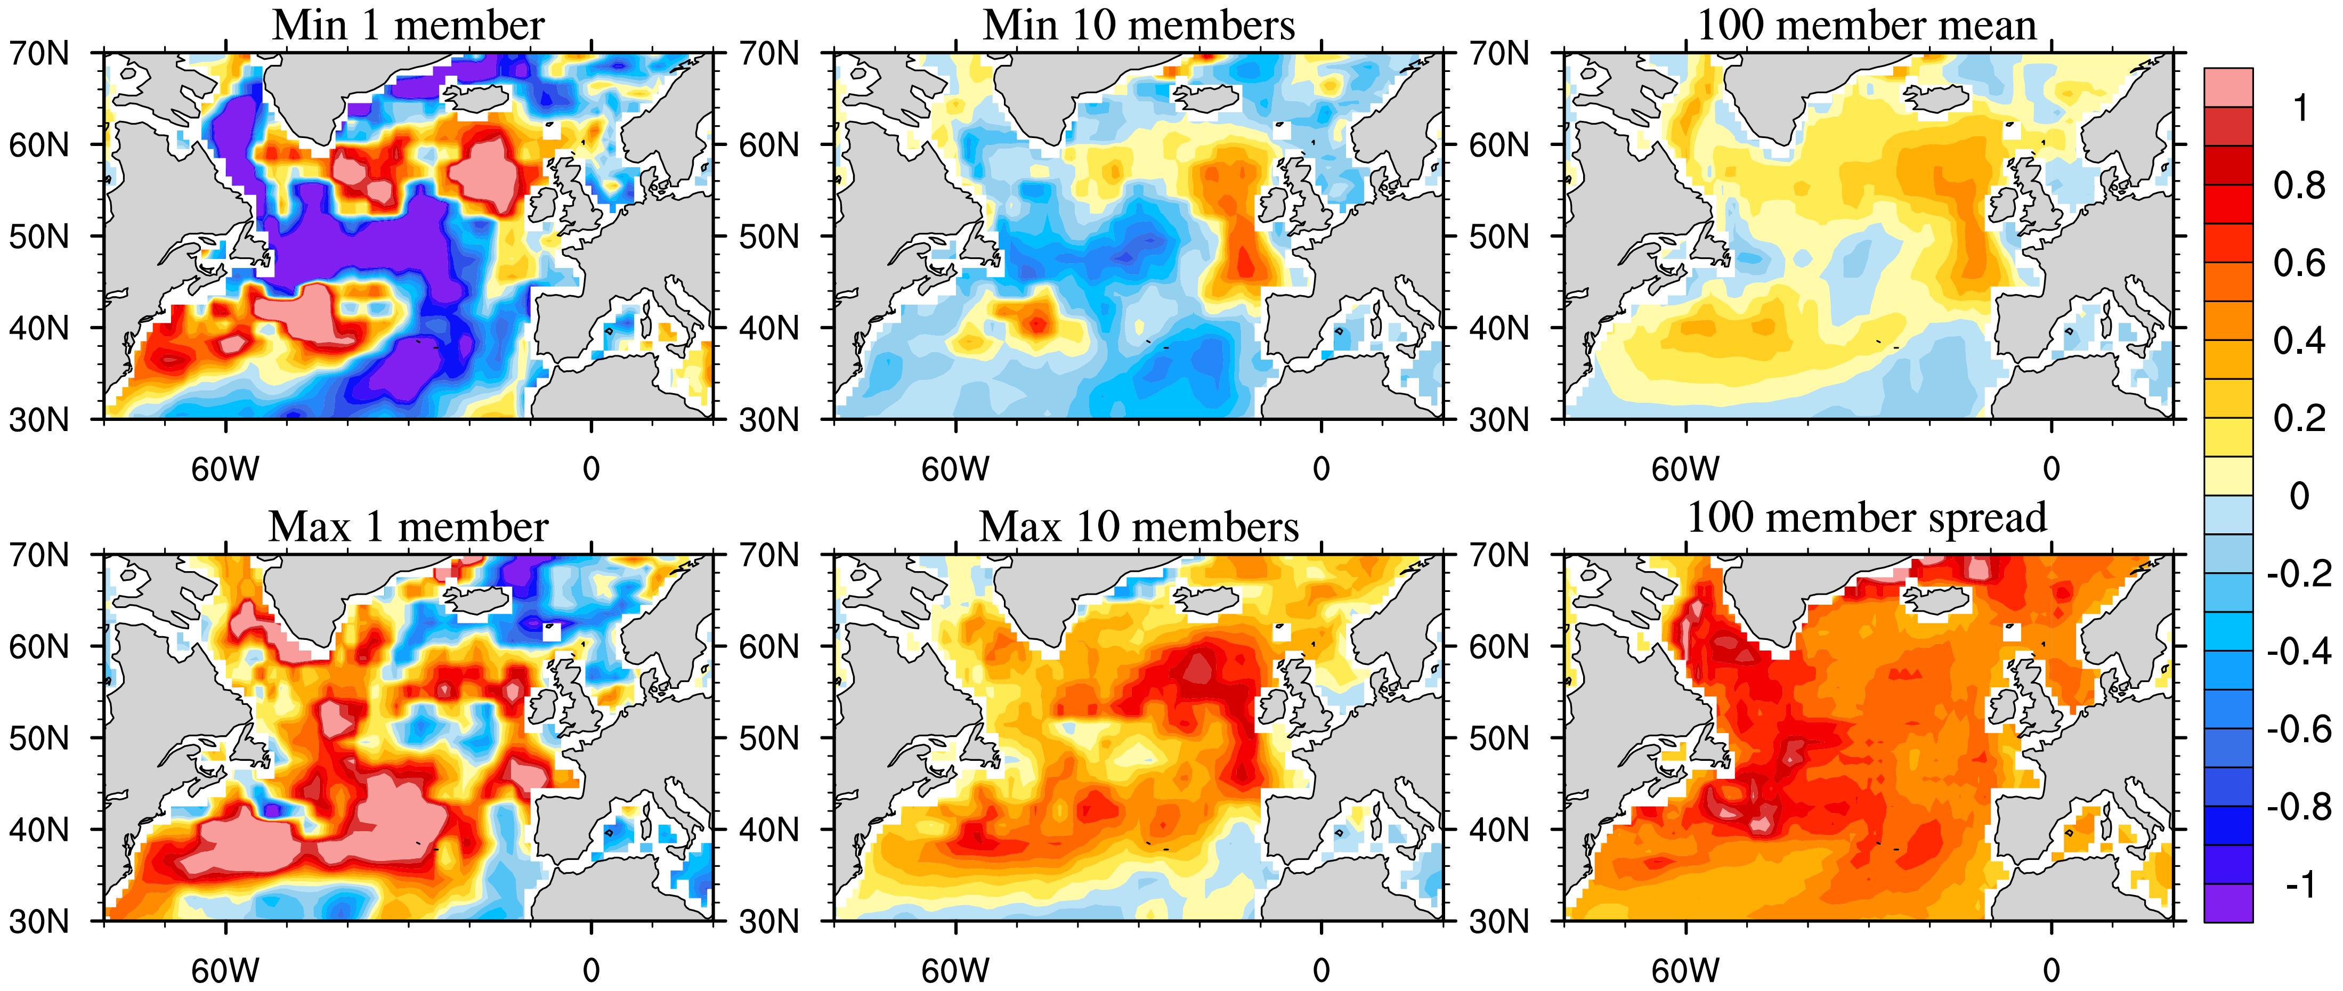Figure S1. Members with contrasting trends of CO2 flux in the North Atlantic during 1992-2001. The left column (a) and (d) shows the single member result with the minimum trend and the maximum trend, respectively. The middle column (b) and (e) shows 10-member ensemble mean result with the minimum trends and the maximum trends. The right column is 100-member ensemble mean (c) and standard deviation (f) of trend.

***Northern Hemisphere*** 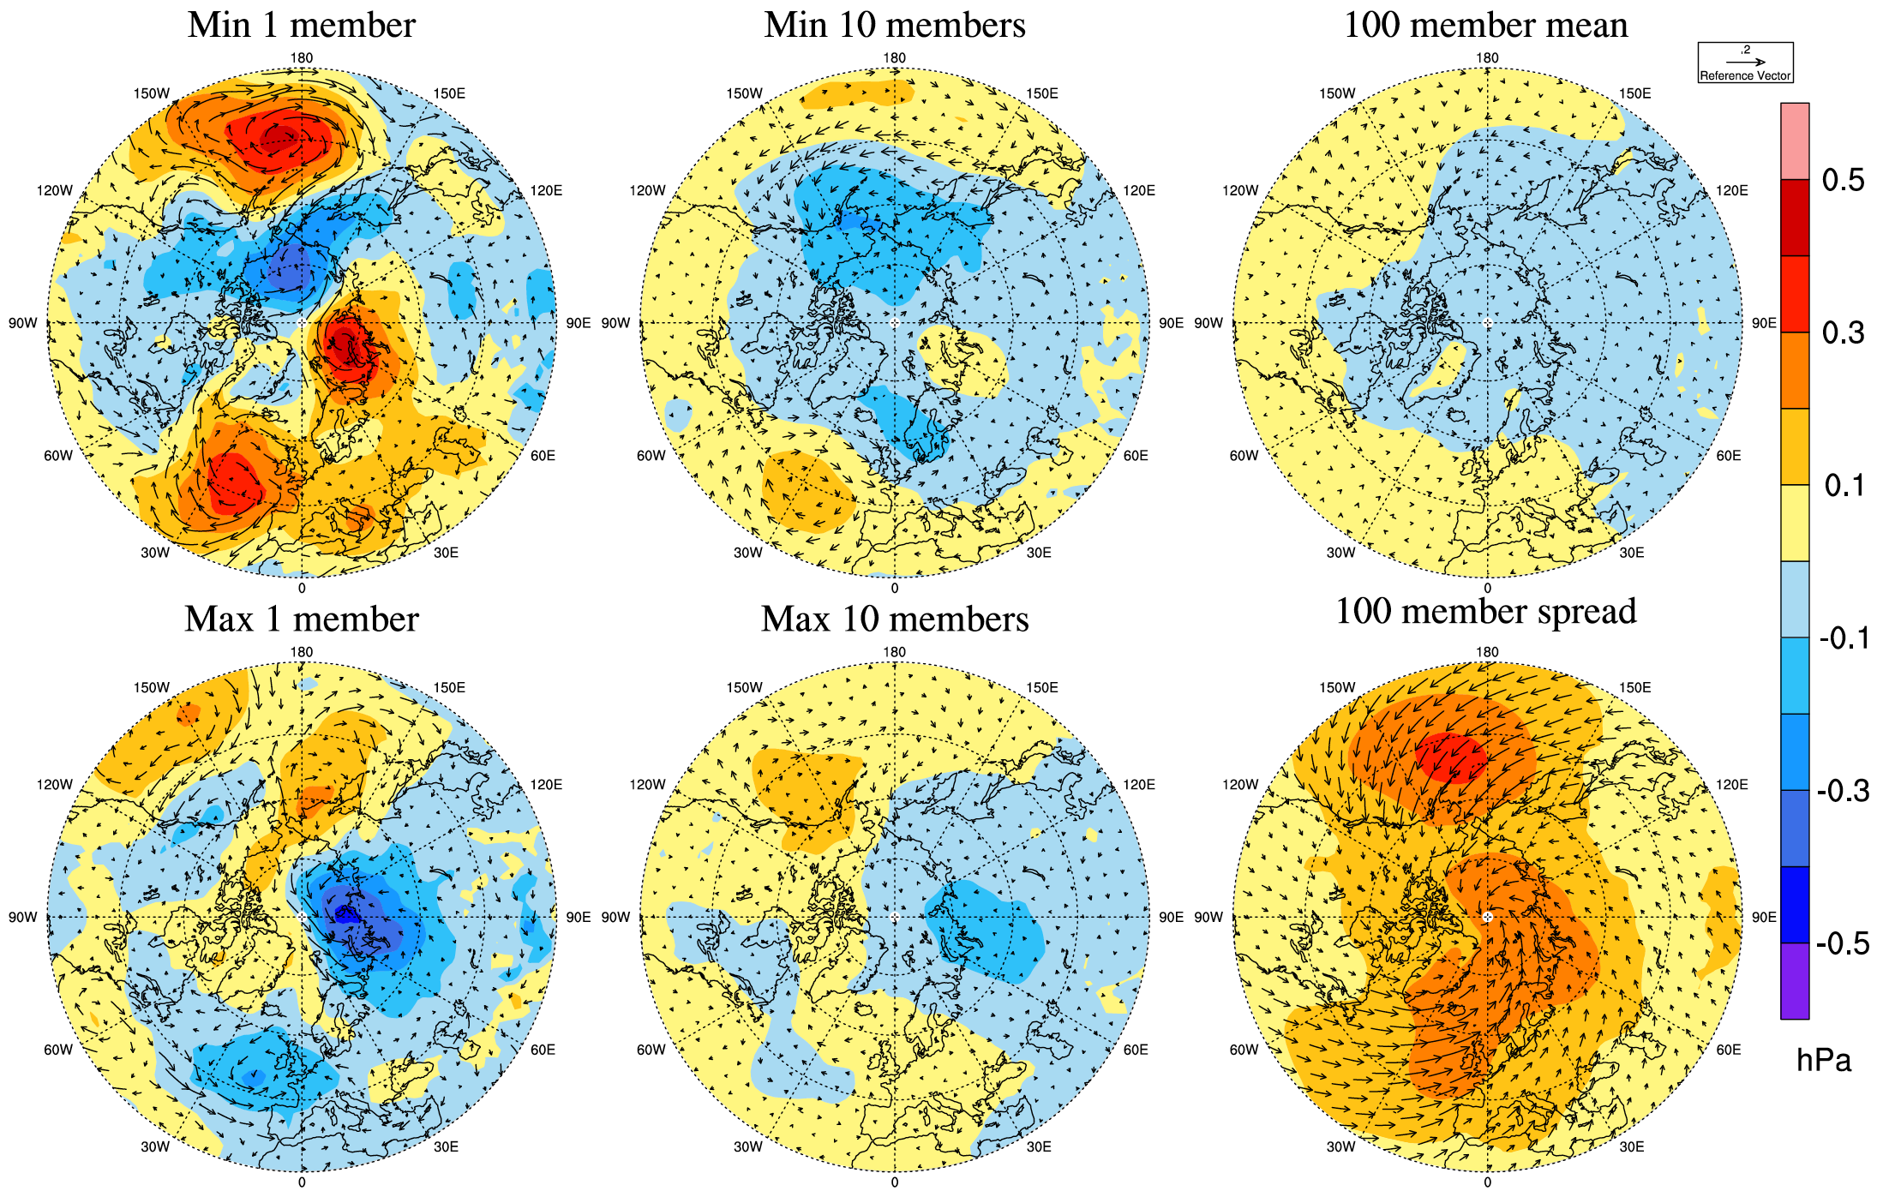

***Southern Hemisphere***

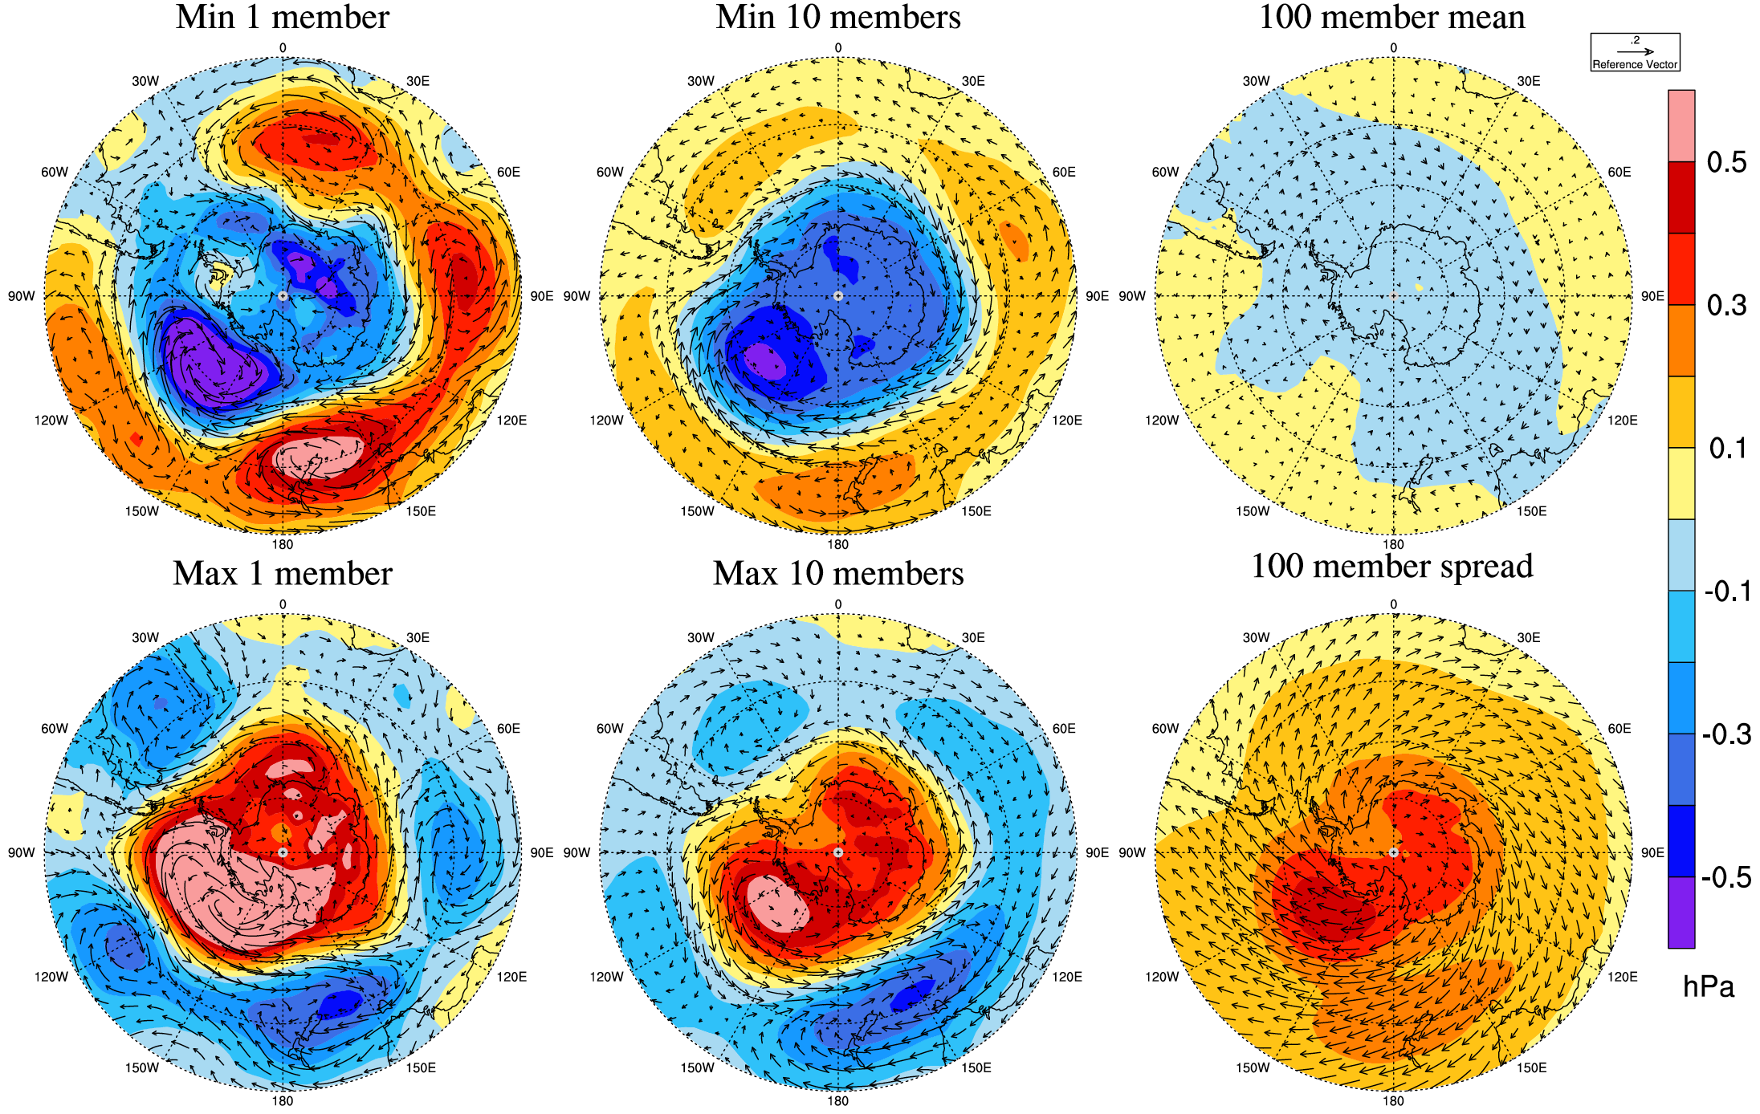

**Figure S2.** Trend of sea level pressure (color) and 10 meter wind (vector) in 1992-2001 in ensemble members with the maximum, minumum, and ensemble mean trend of ocean CO2 uptake.

***Northern Hemisphere*** 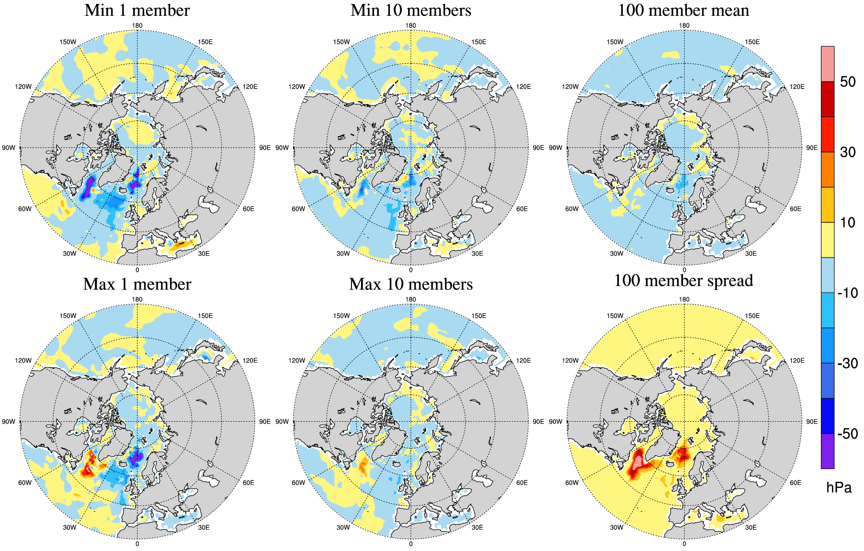 ***Southern Hemisphere***

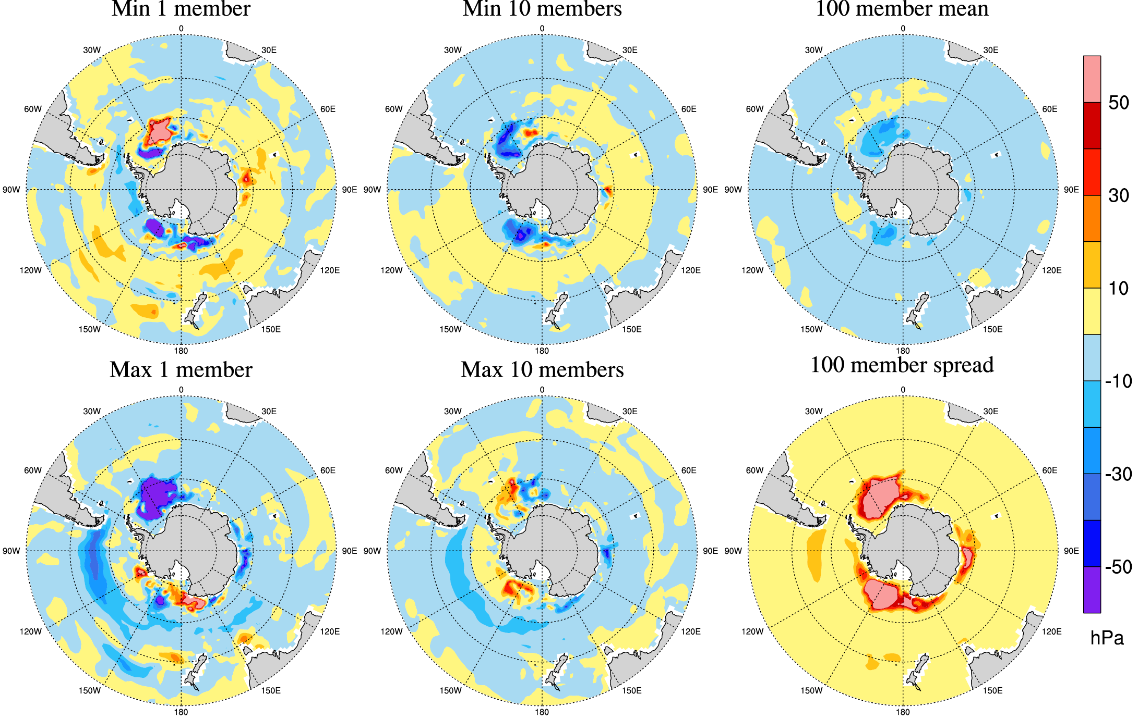

**Figure S3.** Trend of mixed layer thickness in 1992-2001 in ensemble members with the maximum, minumum, and ensemble mean trend of ocean CO2 uptake.

|  |  |  |  |  |  |  |
| --- | --- | --- | --- | --- | --- | --- |
|  | North Atlantic | | | Southern Ocean | | |
| ETH | 5% | 95% | ETH | 5% | 95% |
| 1982-1991 | -0.02 | -0.008 | 0.06 | 0.33 | -0.17 | 0.35 |
| 1992-2001 | -0.03 | -0.02 | 0.05 | -0.46 | -0.14 | 0.54 |
| 2002-2011 | 0.16 | -0.01 | 0.06 | 0.74 | -0.14 | 0.37 |
|  | North Atlantic | | | Southern Ocean | | |
| ETH | min | max | ETH | min | max |
| 1982-1991 | -0.02 | -0.02 | 0.08 | 0.33 | -0.20 | 0.49 |
| 1992-2001 | -0.03 | -0.04 | 0.06 | -0.46 | -0.22 | 0.57 |
| 2002-2011 | 0.16 | -0.02 | 0.07 | 0.74 | -0.19 | 0.51 |

Table S1. 5% and 95% of trend in ocean carbon sink in 3 consecutive periods in North Atlantic and Southern Ocean.